TICKET RAISE IN AMAZON – DIRECT AND DELHIVERY – DIRECT
** TICKETS CAN ONLY BE RAISED FOR THOSE AWB NUMBERS WHICH ARE DIRECTLY TRANSPORTED BY AMAZON AND DELHIVERY, WITHOUT ANY AGGREGATOR**

DELHIVERY – DIRECT:
STEP – 1:
Open https://one.delhivery.com/v2/login
Username – shivam@theaffordableorganicstore.com
Password – _@t5A!Cs4L7$#A$
STEP – 2:
Click the support icon at the left.
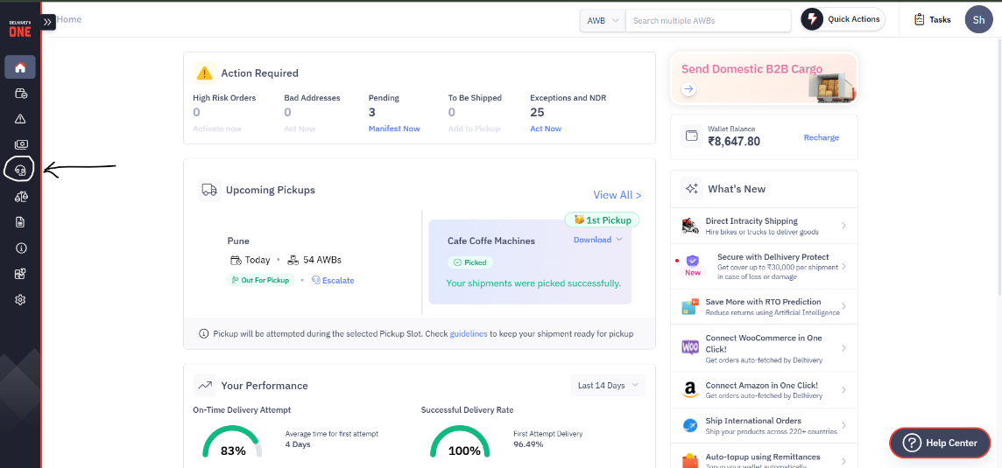

STEP – 3:
Click the Raise a ticket button at top right corner.
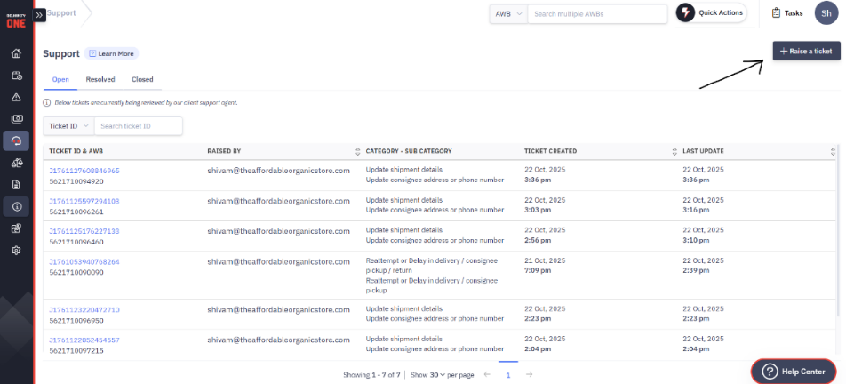
STEP – 4:
Choose appropriate reason, then upload the corresponding AWB no. (s) and click proceed.
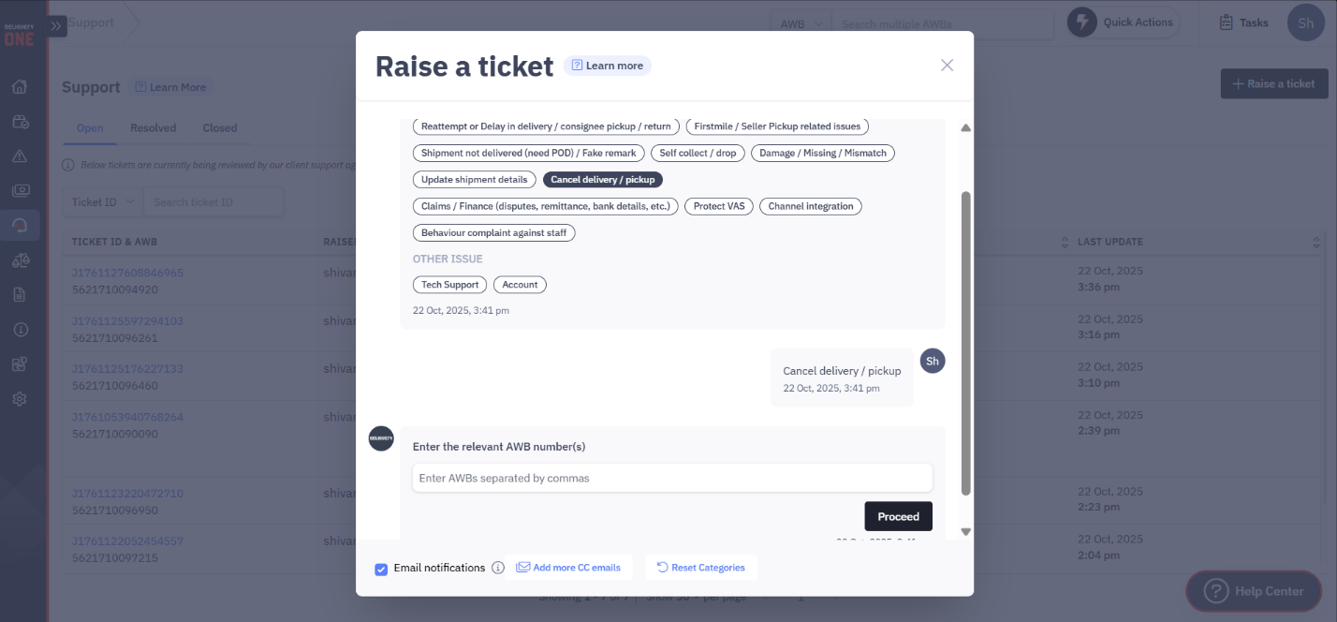

AMAZON – DIRECT:

STEP – 1:
Go to ship.amazon.in
Username - theaffordableorganicstore@gmail.com
Password - TAOS@amazon321
Get the OTP from +9195023 19754
STEP – 2:
Go to Support.
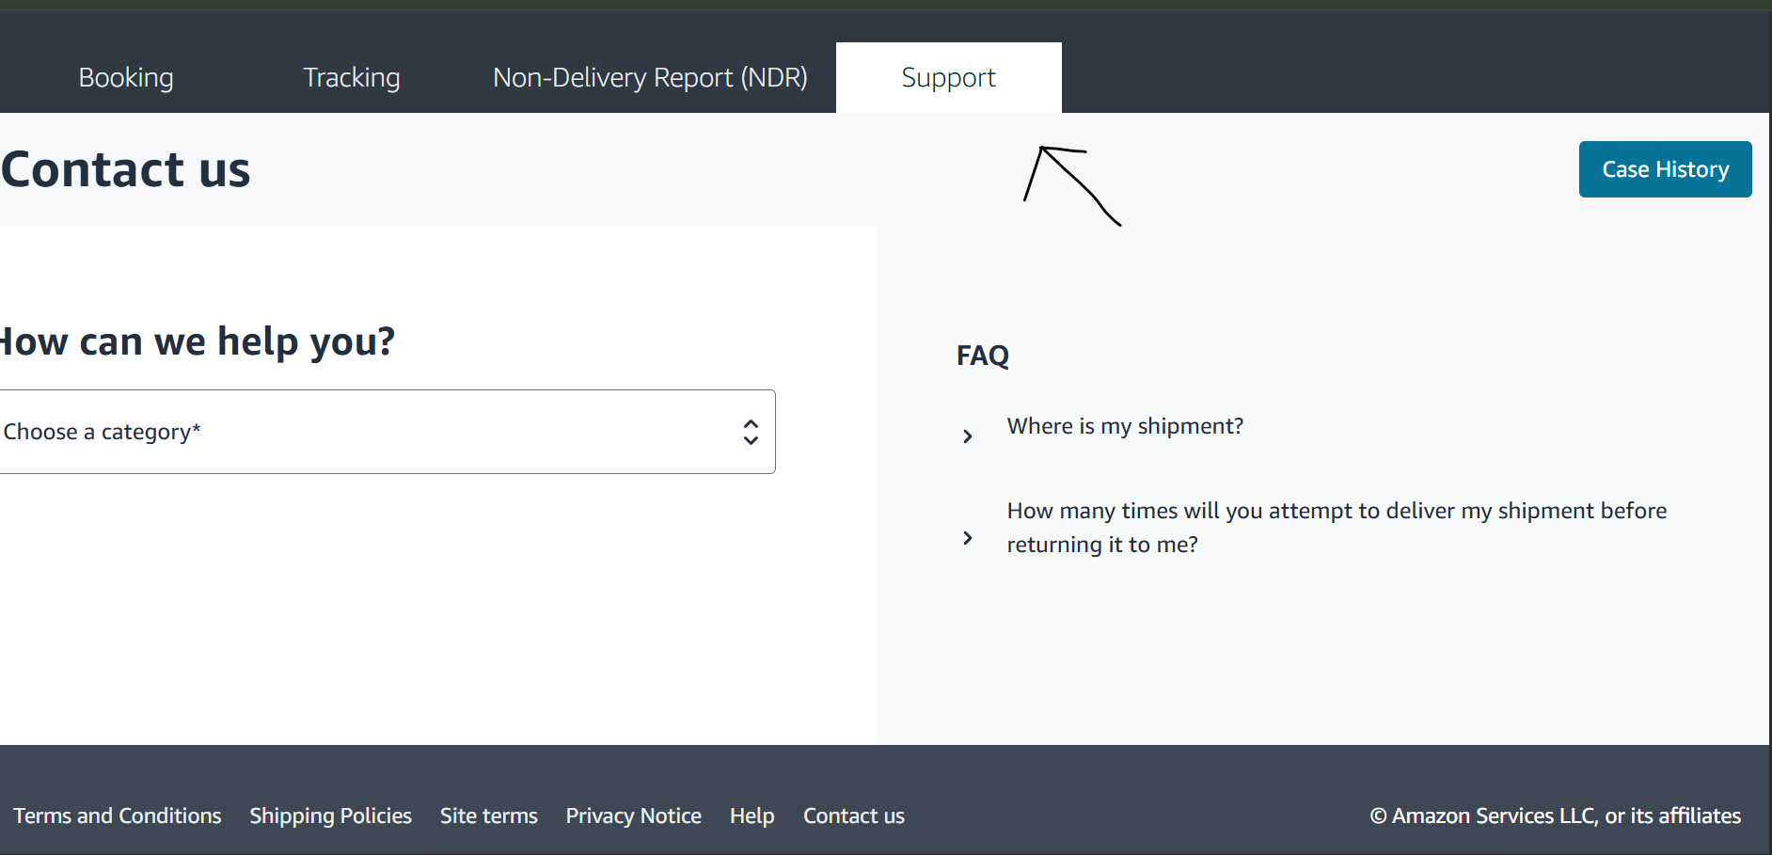

STEP – 3:
Fill the required fields as needed.
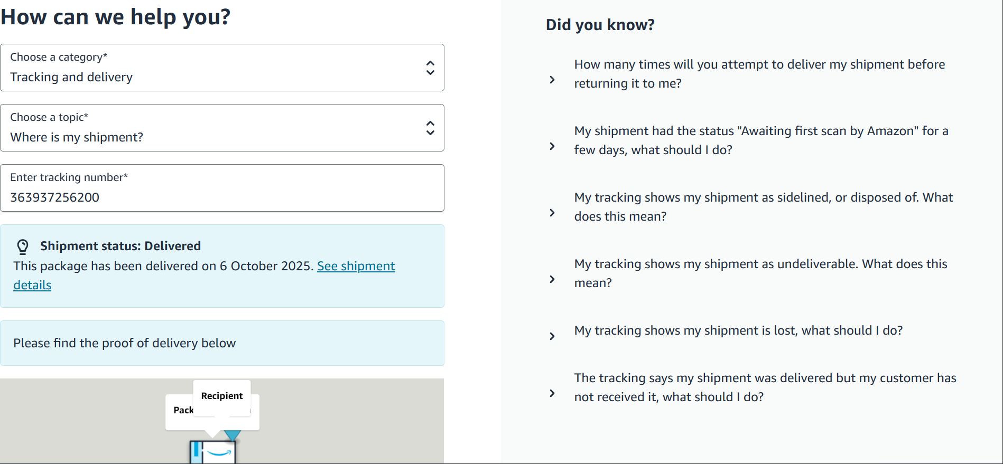
STEP – 4:
At the bottom of the page, if you want to raise ticket, select No.
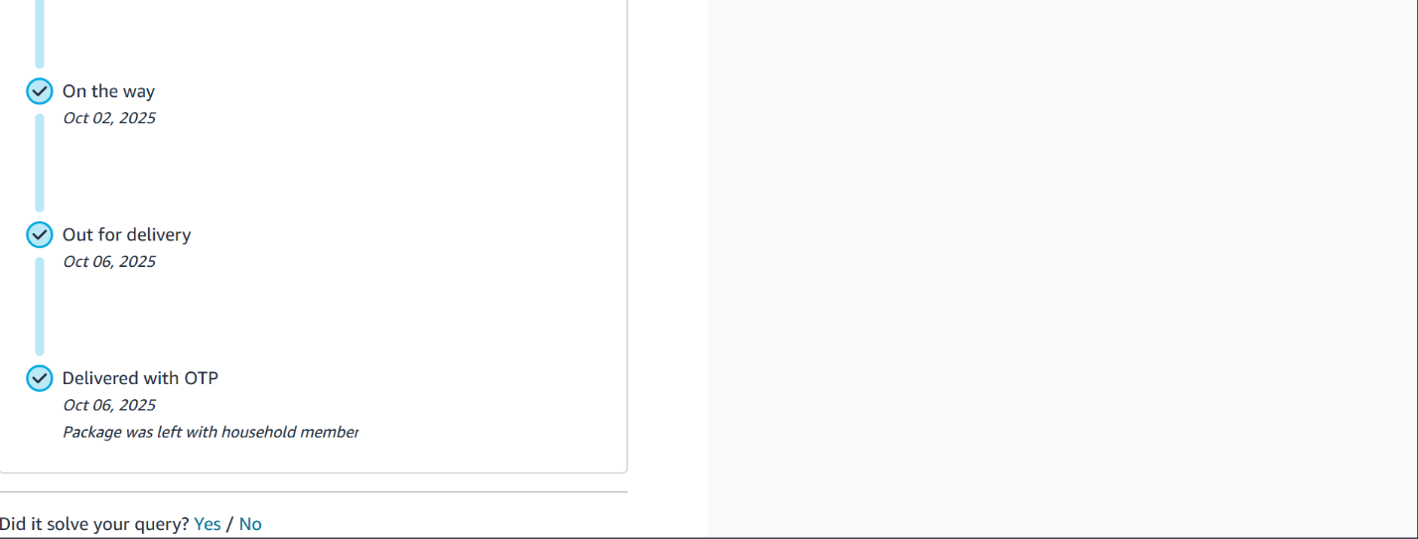

STEP – 5:
Now select contact us.
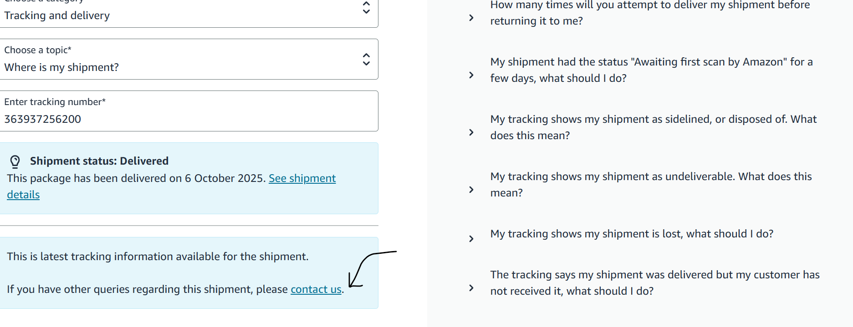
STEP – 6:
Tell your issue mentioning AWB no (must). Ex. – AWB no. 82928222, kindly initiate reattempt asap. Then click submit.
